**Initial Project Planning Template**

|  |  |
| --- | --- |
| Date | 6 October 2025 |
| Team ID | xxxxxx |
| Project Name | Predicting Plant Growth Stages with Environmental and Management Data Using Power BI |
| Maximum Marks | 4 Marks |

**Product Backlog, Sprint Schedule, and Estimation (4 Marks)**

**The backlog is prioritized with the most crucial items (data modeling and core visualization) at the top.**

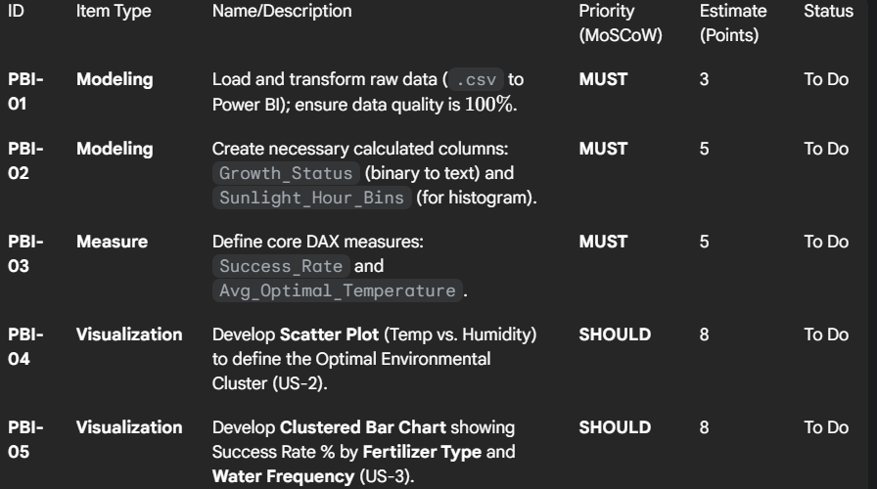

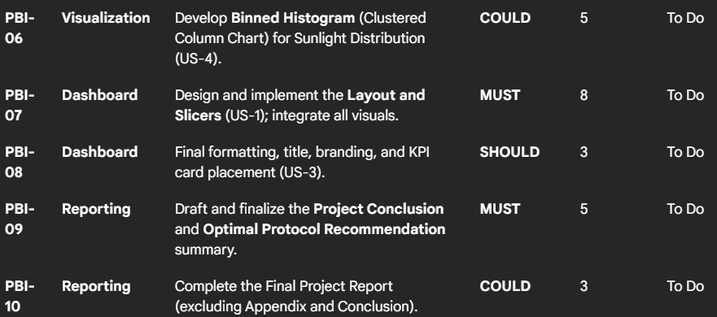

**Sprint Schedule (2 Sprints)**

Assuming a typical analytical project timeframe, the work is scheduled over two one-week sprints.

**Sprint 1: Data Foundations and Core Modeling**

**Duration: [Start Date] to [End Date] (e.g., 5 days)**

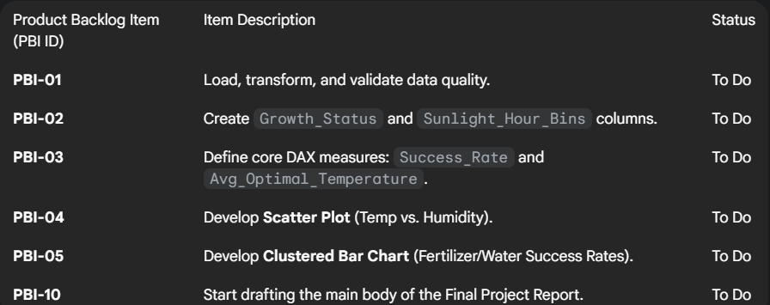

**Sprint Goal**: Establish a complete, clean data model and generate the two most critical visualizations required to define the Optimal Environmental Window and Protocol**.**

**Sprint 2: Visualization Integration and Reporting**

**Duration: [Start Date] to [End Date] (e.g., 5 days)**

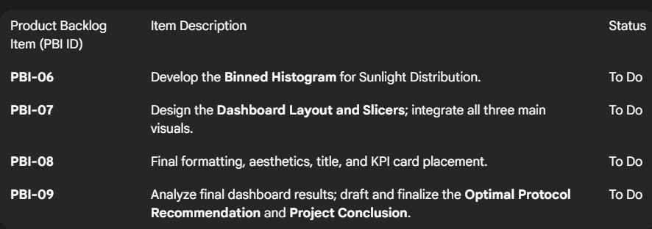

**Sprint Goal:** Complete all visualizations, integrate them into the final interactive Power BI dashboard, and finalize all project documentation and conclusions**.**